Software Overview
The Photonic Sensing software is designed to run on Windows operating system as a desktop application. Its purpose is to provide a user-friendly interface for monitoring signals with the Ocean Electronics’ Ocean SR spectrometer. The software is developed with Microsoft Visual Studio 2026 Community Edition and, therefore, is intended for academic research purposes.
The software's main screen (Figure 1a) has four configuration sections. The Device section allows the user to connect and disconnect the device (Connect and Close device buttons, respectively). The Integration time section allows the user to define the integration time in microseconds, and the Monitoring Config section allows the user to configure the monitoring time in seconds. The Saving options section allows the user to set a name for their experiment, as well as the folder where they want to save the associated files. Finally, the Wavelengths section allows you to perform three types of experiments: a) sensing across a range of wavelengths (Range option), b) sensing at a single wavelength (Value option), or c) sensing independently at a set of user-defined wavelengths (Selected values option). In this last case, the software allows the user to enter the desired wavelengths (Figure 1b).
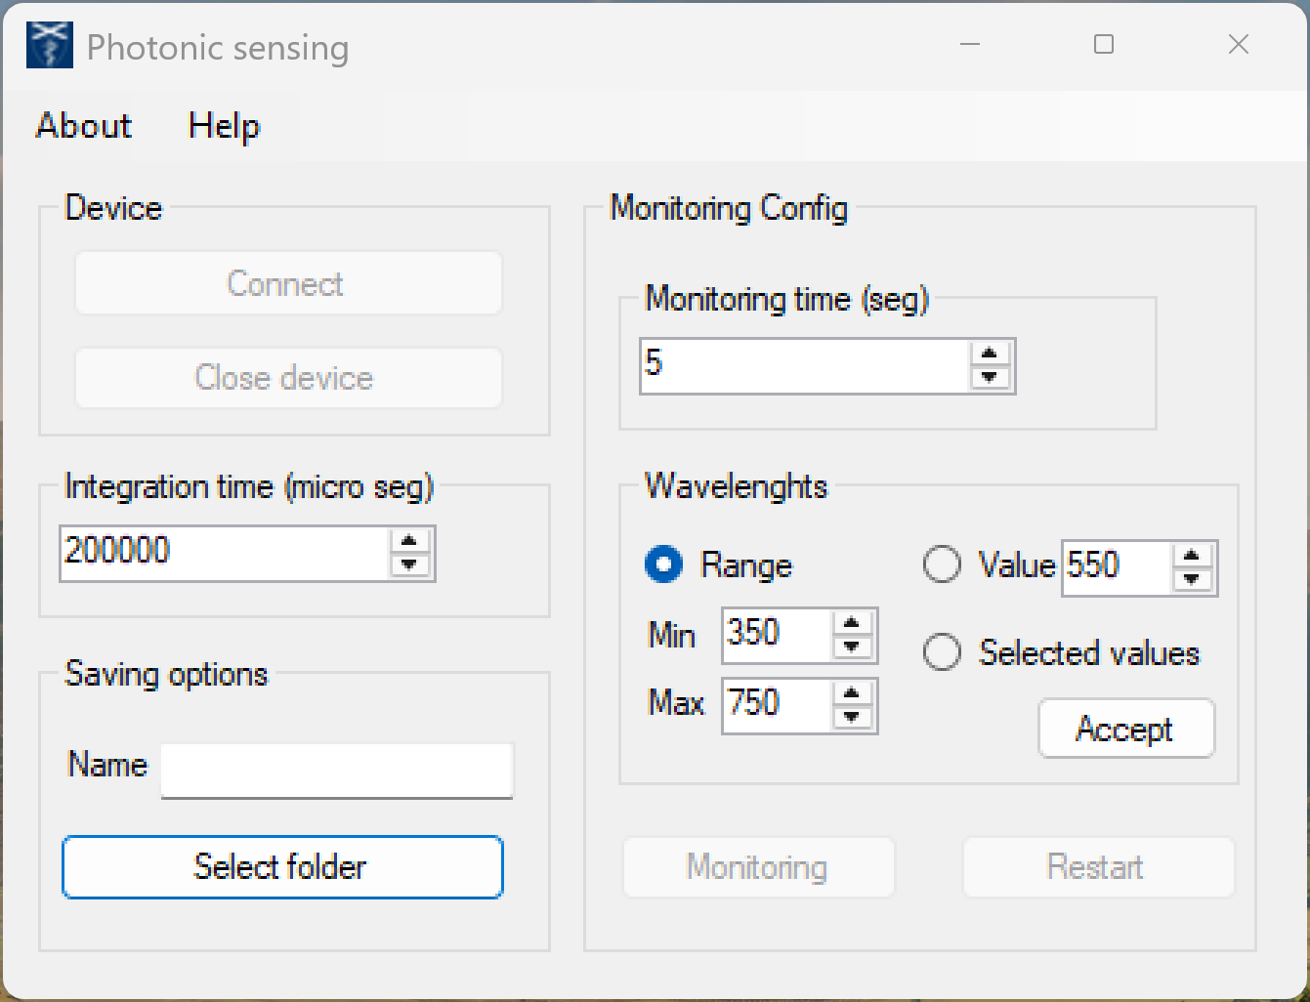 | 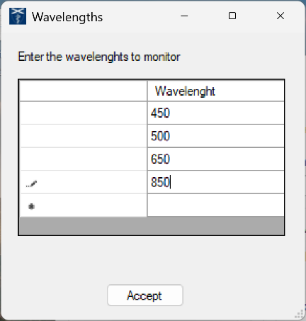
(to) | (b)
Figure 1. Photonic sensing software. (a) Main screen. (b) Screen for setting several wavelengths to be sensed independently.

Once the settings are configured, the Monitoring button is activated, initiating sensing and displaying three graphs (Figure 2): the signal(s) to be monitored (top left), the spectrum (top right), and the phase of the first signal (bottom left). The user can also choose to save only the spectrum files (in .csv format), the signals and phase, the displayed images (in .jpg format), or both. It should be noted that, in addition to the user-defined name, the saved files contain the system date and time, ensuring that they are not overwritten when a new experiment is performed.
The software allows the sensing to be concluded before the established monitoring time is reached by using the Abort Monitoring button, if the user so desires, without this preventing the saving of the results obtained up to that point.
Once an experiment has been performed, the Restart button on the main screen is activated, offering the user the possibility of continuing to sense without disconnecting the spectrometer, either with the initially established configuration or with another of their choice.
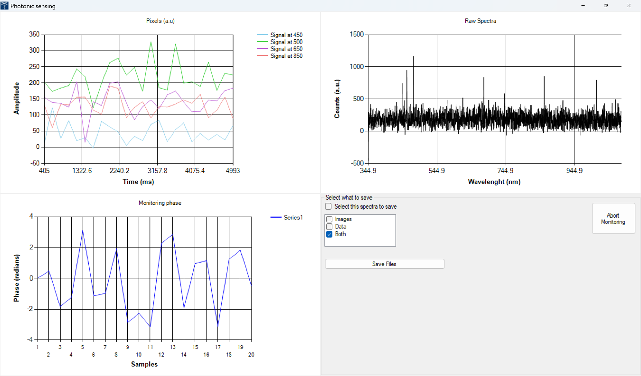
Figure 2. Sensing screen in the Photonic sensing software.

